NPRR Number | 1092 | NPRR Title | Reduce RUC Offer Floor and Remove RUC Opt-Out Provision
Date |  | February 17, 2022
Submitter’s Information
Name |  | Ian Haley
E-mail Address |  | Ian.Haley@VistraCorp.com
Company |  | Luminant Generation Company LLC
Phone Number |  | 512-673-9655
Cell Number
Market Segment |  | Independent Generator

Comments

Luminant appreciates consideration of these comments to express its concerns with Nodal Protocol Revision Request (NPRR) 1092. Luminant respectfully disagrees with the commentary from the Public Utility Commission in support of NPRR1092 at the January 27, 2022 Open Meeting, which did not benefit from full briefing from all parties on the issues at hand in this NPRR. For the reasons laid out below, Luminant cannot vote to endorse NPRR1092 and encourages the Commission, the ERCOT Board, and other stakeholders to carefully consider whether the policies in NPRR1092 are both justified by data and consistent with other policy priorities. Luminant has specific concerns regarding the lowering of the Reliability Unit Commitment (RUC) offer floor, the removal of the RUC opt-out, and the Commission’s unanticipated early intervention in the stakeholder process for this NPRR without providing all stakeholders an opportunity for briefing. The overarching concern, however, is that NPRR1092 embodies multiple watershed policy decisions that will further entrench suppression of market outcomes due to ERCOT’s conservative operations to the detriment of dispatchable generation, which is an outcome diametrically opposed to a number of other stated policy objectives endorsed by Texas policymakers (including the Commission) over the past year.

RUC is an out-of-market tool used by ERCOT when it determines that the set of units that are On‐Line and operating in the market, or that are projected to be brought On‐Line by a unit owner, are not sufficient to meet ERCOT’s desired On-Line reserves. ERCOT has acknowledged that it wants to ensure a higher amount of On-Line reserves than what is procured through market mechanisms in the day-ahead market. This over-procurement has created a distortion in the supply-demand balance and led to ERCOT significantly increasing the number of units that receive a RUC instruction.

None of the proposed changes in NPRR1092 will resolve the underlying problem, which is that ERCOT desires a higher level of reserves than market economics provide. The proposed changes in NPRR1092 likewise will not lower the number of RUCs; they will only further interfere with and artificially lower competitive price formation, complicate generators’ abilities to manage risk, and improperly lower market clearing prices when RUC-committed Resources are price-setting. To properly fix this issue, the market requires sufficient incentives to economically procure the desired operational reserves. NPRR1092 moves in the opposite direction.

ERCOT assesses the reliability of its unit commitment projection following the completion of the Day‐Ahead Market (DAM), and thereafter hourly up to the time of the Real‐Time Dispatch. The reliability need for a RUC is based on the forecast of the physical operating status of the system, Load, and other variables, but not on market economics. If ERCOT’s software determines that the power flow will not otherwise meet its reliability criteria (or desired reserve levels), it produces a set of recommended Resource commitments. ERCOT operators review these recommendations and decide whether or not to execute them, and may also manually select Resources to commit through a RUC. There are no clear limits on ERCOT’s discretion in this area, meaning that ERCOT can and has used RUC to commit units before the unit’s owner is able to evaluate and make commitment decisions based on market signals. This has been markedly clear starting in mid-2021; 2021 saw roughly an 1,800% increase in RUC Resource-hours over 2020, with most of that occurring in the second half of the year:
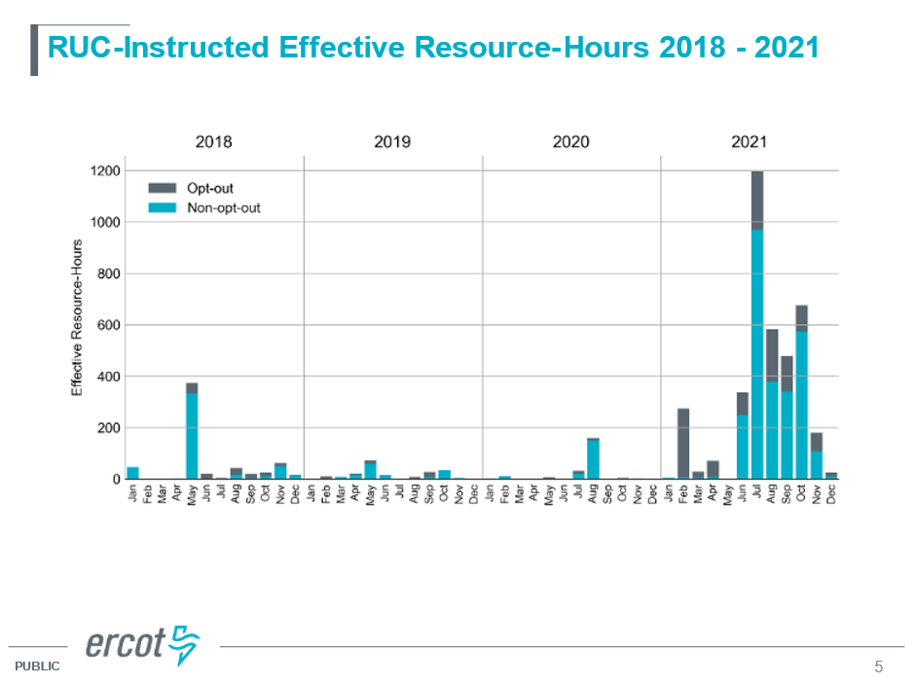

Notably, despite the significant increase in RUC activity since June 2021 (89% of the RUC intervals since January 2021), the incidence of prices exceeding $1,500/MWh (inclusive of price adders) has been exceedingly rare – only 9 SCED runs. Additional information substantiating this point is included in the Appendix. This is an important point to consider, as it simultaneously demonstrates that (1) the RUC offer floor at $1,500/MWh is working as intended to keep out-of-market capacity behind competitive offers; and (2) there is not any pressing urgency to implement this change:

Similarly, the impetus for elimination of the RUC opt-out has not been thoroughly analyzed and instead argued in broad terms, often pejoratively referring to it as a “free option” for a Resource owner. Luminant contends that this, too, is a misleading mischaracterization, as it could just as easily be described as a “free option” for ERCOT. The rules for opting out of a RUC instruction require a Resource to be made available for the entire RUC instruction time period and the Resource must forego any make-whole supports from RUC Settlement – so the risk sits entirely with the Resource owner. Furthermore, ERCOT’s RUC activity since 2021 has increasingly focused on older, low-capacity factor units, meaning that if the RUC opt-out is eliminated but RUC activity continues unabated, the already scant opportunities for these units to deliver positive value will further diminish and the economic sunset of these very dispatchable units upon which ERCOT is relying for its new conservative operating posture will be hastened:

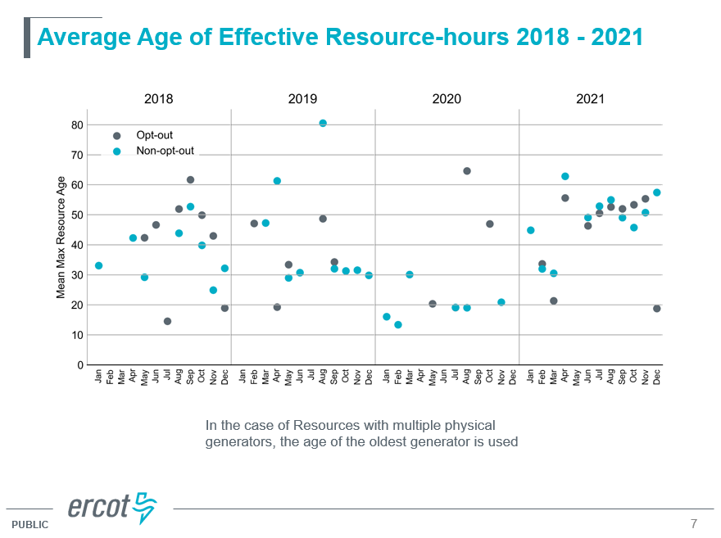
Finally, for all of the foregoing reasons, it is unclear what makes the proposed policies in NPRR1092 necessary to move forward at this time. The Commission has been clear that market design changes should attract and retain dispatchable generation, but those policies are not yet in place. NPRR1092 will run counter to those objectives.

- Reduction of the RUC price floor to $75 undermines market design goals

The $1,500/MWh offer floor for RUC was determined through a stakeholder compromise associated with the creation of the Reliability Deployment Price Adder through NPRR626, Reliability Deployment Price Adder. The compromise was based on the principle that out-of-market actions, like a RUC, should be offered in a way to minimize impacts to the efficient operation of the market. Arguably, this would be achieved by offering RUC MWs at the price cap—in essence negating the out-of-market actions. A compromise between load and generation was to have a RUC offer floor of $1,500 because it represented a price that was high enough to ensure that RUC units were dispatched above their Low Sustained Limits (LSLs) “last in line” behind all but the most expensive competitively-offered units. This is especially important when ERCOT is using RUC as a tool to add capacity to the grid at times that market prices are not signaling a need for such additional capacity.

Luminant believes that the changes proposed by NPRR1092 will materially undercut the valuable work that the Commission has undertaken in the past year to initiate changes intended to support the economic incentives necessary to “foster the development and maintenance of adequate and reliable sources of power.” NPRR1092 will undercut that work by displacing economic offers from willing sellers in a way that will lower market prices instead of sending an economic signal that is either driven by market forces or that market forces had not adequately resolved one or more reliability needs. This will interfere with Market Participants’ incentives to address reliability needs economically and will thus impair the normal forces of competition that should determine the price of wholesale electricity under a given reliability objective.

Luminant agrees with Chairman Lake’s repeated observation that “the cure for high prices is high prices,” because high prices drive market discipline that competes away pricing anomalies. NPRR1092, however, effectively prescribes that the cure for the perceived risk of high prices is government price controls. This is because the combination of ERCOT frequently “utilizing the RUC process to procure an excess reliability margin” combined with the materially reduced RUC price floor of $75/MWh will in effect create a soft wholesale price cap equal to the RUC price floor any time that ERCOT utilizes RUC. That phenomenon has already been observed following ERCOT’s expansion of Non-Spinning Reserve (Non-Spin) procurement starting in July 2021 (in this way, NPRR1092’s RUC price floor change will extend and add to the existing price-suppressive effect of heavy Non-Spin procurements). It is worth noting that, excluding Winter Storm Uri, from January 2021 through January 2022, the ERCOT System Lambda reference price has only exceeded $1500/MWh on three occasions. This highlights that the practical impact of keeping the RUC floor at $1500/MWh is low, so the high concern has more to do with abandonment of the market philosophy that out-of-market actions should have the least impact on competitive outcomes.

Not only is setting the RUC floor at $75/MWh not a market outcome, it provides additional incentives to dissuade hedging, as load will know that prices will fall below this new RUC floor in all but the most scarce events. This will perversely push ERCOT back towards the “crisis-based business model” that policymakers including the Commission have rightly sought to pivot away from. Market signals that dispatchable generation economics rely upon will struggle to exceed the soft $75 price cap during times of true scarcity when there is nothing left to RUC, even if doing so would achieve proper policy objectives. In this way, NPRR1092 will instead push the ERCOT market towards becoming even more dependent upon intermittent renewables and limited-duration energy storage – and in turn more susceptible to reliability concerns that only “RUCable” Resources can resolve.

ERCOT is still an energy-only market. There is currently no market value attributed to capacity outside of short-term Ancillary Service awards, and therefore there is appropriately not a must-offer requirement. Must-offer requirements are a reasonable requirement in exchange for some consideration, but ERCOT provides none. Energy price expectations, therefore, are the fundamental driver of unit commitment in ERCOT. The NPRR1092 business case sadly speaks about this market fundamental in the past tense:

“The Reliability Unit Commitment (RUC) offer floor was put into place in a market construct in which self-commitment was relied upon and RUC was infrequent. Recently, ERCOT has been utilizing the RUC process to procure an excess reliability margin.”

This motivation provides no analysis regarding the appropriateness of ERCOT’s more frequent utilization of the RUC process; it instead takes for granted that market-driven commitment cannot achieve ERCOT’s desired operating reserves, and in the next breath concludes that an out-of-market action (RUC) should now be considered equivalent with a competitively procured Ancillary Service (Non-Spin) for purposes of converting reserves into energy. This is a false equivalence, however, given that Non-Spin is provided by an economically committed Resource that receives an Ancillary Service capacity payment to make reserved capacity available on short notice. RUC units are not economically committed, receive no capacity payment, and receive only strictly-defined compensation to cover certain costs unless the RUC is “bought back” (an option that NPRR1092 proposes to eliminate). Together, this portends a fundamentally unsustainable market construct wherein capacity is uncompensated yet effectively subjected to a backdoor must-offer requirement in the DAM (because of clawback penalties) for a Real-Time energy market that would rarely send adequate price signals due to forced overcommitments. To be clear, Luminant is not arguing that RUC should be used to send scarcity price signals; rather, Luminant is simply advocating that RUC should not impede the effectiveness of other market scarcity pricing mechanisms.

The Public Utility Commission recently directed ERCOT to implement changes to the Operating Reserve Demand Curve (ORDC), explicitly contemplating the incentives for economic self-commitment that the revised ORDC should create, as well as sending the strongest price signals before ERCOT reaches true scarcity conditions. Those criteria were appropriate; Luminant supported and still supports that change as a means to use market design tools to achieve ERCOT’s more risk-averse modus operandi. The Commission should be aware, however, that in addition to any reduction in system lambda from reducing the RUC offer floor from $1,500/MWh to $75/MWh, there may also be a price suppressive impact on the ORDC adder itself because of the interaction in the loss of Load probability calculation of the ratio between On-Line and Off-Line reserves. While not all On-Line RUC capacity is counted towards the ORDC reserves, the more On-Line reserves there are, some may still be counted in the ORDC reserves, and RUC-displaced peaking capacity that does count as reserves will compound the downward pressure on ORDC prices.

Moreover, those recent ORDC changes have been in effect for only 1.5 months – an insufficient period of time for Market Participants and ERCOT to observe and evaluate outcomes under the new ORDC parameters, as well as adjust to it. The ORDC changes implemented by Commission order at the beginning of this year should at the very least be given an opportunity to demonstrate their effectiveness – without the interference of increased Ancillary Service procurements and RUC instructions used to procure excessive reserves – or uncover the need for additional modifications to address instances where the revised ORDC does not align with ERCOT’s preferred level of operating reserves (e.g., moderating the impact of increased Non-Spin procurements on ORDC reserves). This should address the root cause underlying NPRR1092 (use of RUC to procure excess reserves) without eroding the energy price signals that dispatchable (i.e., RUC-able) generators in the ERCOT market depend upon to maintain their economic viability, and without which the ERCOT market will increasingly flirt with true scarcity conditions under its changing Resource mix.

Finally, the Reliability Deployment Price Adder (RDPA) would also likely be impacted by interjecting RUC Resources in the economic dispatch queue. This is because NPRR1092 would increase the frequency of RUC units being dispatched above LSL and the RDPA, when dealing with RUC Resources, will only practically account for the impact of RUC LSLs on system lambda (since it was presumed at the time that any RUC capacity above LSL would be dispatched only behind the majority of competitive offers thanks to the RUC offer floor).

- RUC opt-out elimination will add more uncertainty approaching real-time operations while adding costs

NPRR1092’s proposed elimination of the RUC opt-out similarly contravenes the energy-only economic commitment nature of the ERCOT wholesale model.
The introduction of the option for a unit owner to opt out of RUC was itself a compromise. In 2011, Exelon and Calpine filed NPRR416, Creation of the RUC Resource Buyback Provision, which proposed to change the Nodal Protocols to remove the revenue clawback penalty for Resources that were committed by ERCOT through RUC. Exelon and Calpine cited comments from Potomac Economics’ (the ERCOT Independent Market Monitor (IMM)) Dr. Patton in the proceeding to adopt the original Nodal Protocols where Dr. Patton had recommended eliminating the RUC clawback penalties.

ERCOT expressed concern that elimination of the RUC clawback penalties would lead to inefficient commitment decisions. So, after several months of stakeholder discussions regarding then-proposed NPRR416, the proponents changed the NPRR so that the RUC clawback penalties would stay in place, but unit owners would have the ability to “opt out” or “buy-back” the unit from ERCOT, so long as they self-committed the unit for the same hours. That is, when a unit owner invokes the RUC opt-out, it both avoids the RUC clawback penalties and forfeits RUC make-whole payments on the unit. Thus, the unit owner takes on all of the risk that the Real-Time Market (RTM) prices will ultimately be compensatory. ERCOT supported the approval of the NPRR “as it helps Resource owners manage financial risk,” and the ERCOT Board approved it unanimously. It stands to reason, therefore, that if the RUC opt-out is ultimately removed, the elimination of the RUC clawback penalties should be reconsidered.

The RUC opt-out allows a resource to follow emergent economic signals that align with reliability needs, while taking the risk of uplift costs off of Loads. In other words, it promotes a market solution over a regulatory solution. Consequently, retaining the RUC opt-out promotes competitive market outcomes.

By contrast, eliminating the RUC opt-out effectively creates a backdoor must-offer requirement for units that want to avoid RUC (or the RUC clawback penalties), which no other electricity market requires in the absence of market valuation of and compensation for the unit’s capacity.

Proponents of eliminating the RUC opt-out tout that it will incentivize greater self-commitment earlier. This may or may not be true, but it is unclear why generators would be more willing to commit uneconomic units, with the hope of covering their costs, based on the changes proposed in NPRR1092. While today many of the units at issue have a practical risk management value to their owners, it seems more likely that those operators would change their risk management strategy rather than commit units uneconomically.

Today that risk management value can be re-evaluated with best available information if/when ERCOT issues a RUC instruction for that unit. If NPRR1092 strips the RUC opt-out capability, however, then generators will need to make commitment decisions earlier and with incomplete information. In particular, because of the timing in ERCOT’s RUC commitments, generators may not have sufficiently accurate information regarding gas prices, wind, solar, or load forecasts. Eliminating the RUC opt-out precludes portfolio managers from managing risks and maximizing the value of the assets under their control, since an economically un-committed unit will still have value to a fleet manager in covering unexpected short positions. While some of that risk may be manageable financially, it may be less efficient and more costly to do so. Furthermore, it is Luminant’s experience that RUC compensation fails to fully remunerate for ERCOT’s confiscation of the asset.

Compounding these factors is the fact that ERCOT’s increase in RUC activity has generally targeted older units that already operate with lower capacity factors:

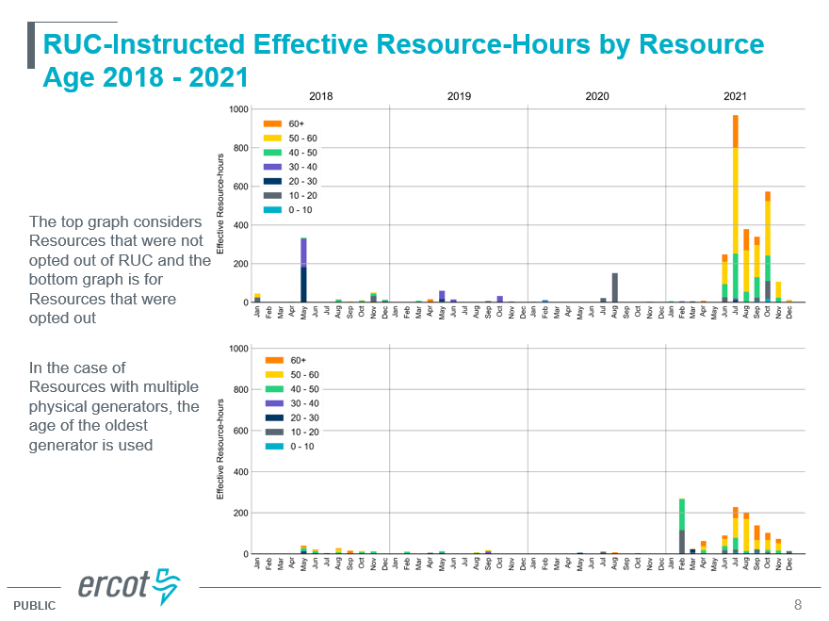

This puts them in an economic tight spot, because they are economically dispatched less frequently but also must recover their full costs in fewer intervals or else become wholly uneconomic to continue operations. While RUC make-whole provisions do cover marginal costs, a unit that is only committed via RUC cannot remain economically viable. The RUC opt-out, in addition to providing an opportunity for units to respond to market incentives rather than regulatory ones (a benefit of principle), also allows these units to provide additional value to their owners’ portfolios for risk management – a private incentive that benefits the broader ERCOT system in a practical way by helping to support these dispatchable units’ continued operations, adding to the grid’s resiliency.

These dynamics will yield at least two net negatives: (1) uncompensated and arguably unlawful must-offer requirement for uncommitted units at risk of RUC; and (2) added cost to market participants to manage contingency risks. These reflect a fundamentally different perspective of NPRR1092’s business case claim regarding commitment “inefficiency.”

Aside from that disputed efficiency argument, the other primary argument advanced by some NPRR1092 proponents has been assertions of potential market power abuse. Luminant struggles to understand this concern given the robust and multi-layered protections against market power abuse in the ERCOT market: statutory limitations on market share, utilization of voluntary mitigation plans by large generators, and Real-Time offer mitigation when non-competitive constraints are violated, not to mention oversight and enforcement authority held by the Commission and informed by the IMM. Luminant and other NPRR1092 opponents have repeatedly noted throughout the stakeholder process that concerns about market power abuse can and should be investigated by the IMM, and if warranted, pursued by the Commission’s Division of Investigation, Compliance, and Enforcement (DICE). The broad undermining of the ERCOT market structure for all Market Participants is not justified by unsubstantiated speculation about potential market power abuse.

- The Commission benefits from soliciting input from multiple stakeholders before issuing a decision, particularly on a matter working through the ERCOT stakeholder process

Finally, Luminant has general concerns about the Commission’s unanticipated early intervention in the stakeholder process for this NPRR without providing all stakeholders an opportunity for briefing. Luminant recognizes that reasonable minds can and will disagree, particularly on complex issues such as electricity market policies. The ERCOT stakeholder process exists to allow discussion and vetting of such complex issues, which generally results in better policies. By design, the Public Utility Commission acts as both the ultimate approver of ERCOT Protocol changes as well as the arbiter of disputes regarding ERCOT Protocol change proposals.

This latter point is important, because it highlights that the Commission’s key role in the stakeholder process is to ensure that the ERCOT Protocols are consistent with the overarching policy objectives of the state of Texas. When a controversial NPRR or other ERCOT rule proposal comes along (such as NPRR1092) it is critically important that the Commission, as arbiter of Protocol disputes, maintain an impartiality with respect to Protocol (or other ERCOT Binding Document) Revision Requests unless or until (1) an appeal has been brought to the Commission, and the Commission has been duly briefed by all interested parties; or (2) a Revision Request to implement a Commission order is moving in a direction that is inconsistent with the Commission’s stated or intended effect. This is all the more important when the proposal is stakeholder-driven.

There is no Commission order directing implementation of the policies embedded in NPRR1092, nor has any stakeholder appealed a decision of the ERCOT Board related to NPRR1092 to the Commission. Indeed, Luminant and other stakeholders were surprised to learn of the Commission’s strong interest in NPRR1092 only a few working hours ahead of the January 27 Open Meeting. Accordingly, the Chairman’s memorandum outlining a specific outcome in NPRR1092 prior to its consideration by the Technical Advisory Committee (TAC) and the ERCOT Board that came without the benefit of briefing by interested parties besides the IMM represents a procedural concern.

Granted, the Commission has ultimate authority over ERCOT and could simply have made the same decision after the ERCOT Board had considered and acted on NPRR1092. But at least in that instance, the Commission could make that decision with the benefit of a full record regarding the potential impacts of the change.

Luminant understands and appreciates the extraordinary scope and pace of work that the Commission has undertaken with urgency in the wake of Winter Storm Uri. The demands placed upon this Commission by Texas policymakers, the citizens of Texas, and Market Participants (including Luminant) are significant and unprecedented, often requiring accelerated procedural schedules and only streamlined opportunities for feedback. Luminant supports the Commission taking such measures where required (e.g., by statute or rule). However, for matters that do not have specific timelines requiring accelerated decision-making (such as NPRR1092), Luminant respectfully requests that the Commission either permit normal procedures to be followed to completion or at a minimum solicit briefing from interested parties before providing direction on pending matters in the stakeholder process.

Revised Cover Page Language
None
Revised Proposed Protocol Language
None

- Appendix

The following charts compare RUC HSLs (semi-transparent orange, right-hand vertical axis) with Real-Time prices (dark/light blue & green, left-hand vertical axis). The horizontal red dotted lines delineate the $75/MWh and $1,500/MWh price thresholds. Note that the vertical axis ranges are fixed to support comparison, but results in the pricing data being clipped during Winter Storm Uri in the February chart.
There are only three instances (two in April 2021 and one in June 2021) where the blue line exceeds the $1,500/MWh red horizontal line during a RUC event. This demonstrates that the $1,500/MWh RUC offer floor is performing its intended function of putting RUC capacity behind competitive offers in the supply stack. Additionally, the effective soft price cap at $75/MWh is much more pronounced starting in July 2021, coincident with ERCOT’s implementation of increased ancillary service procurements. Lowering the RUC offer floor to $75/MWh would exacerbate this dynamic.

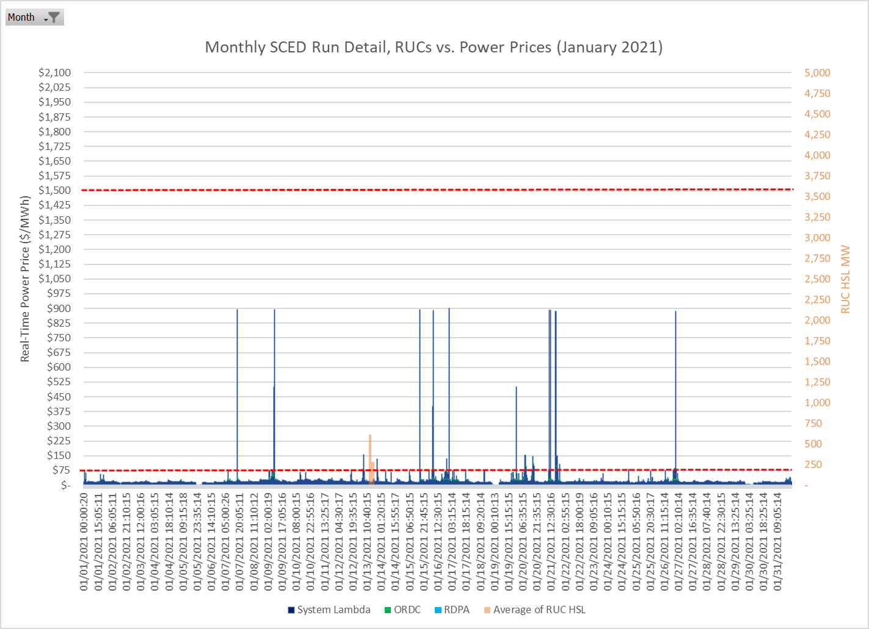

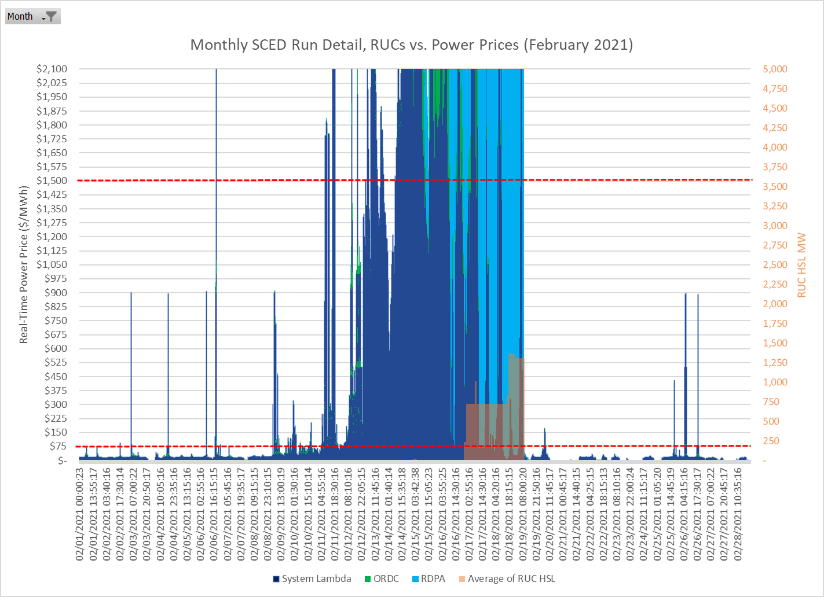
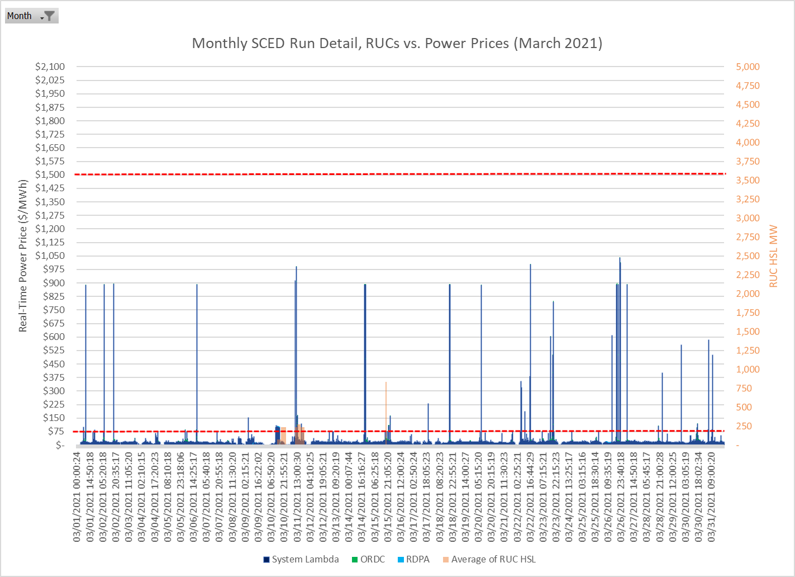
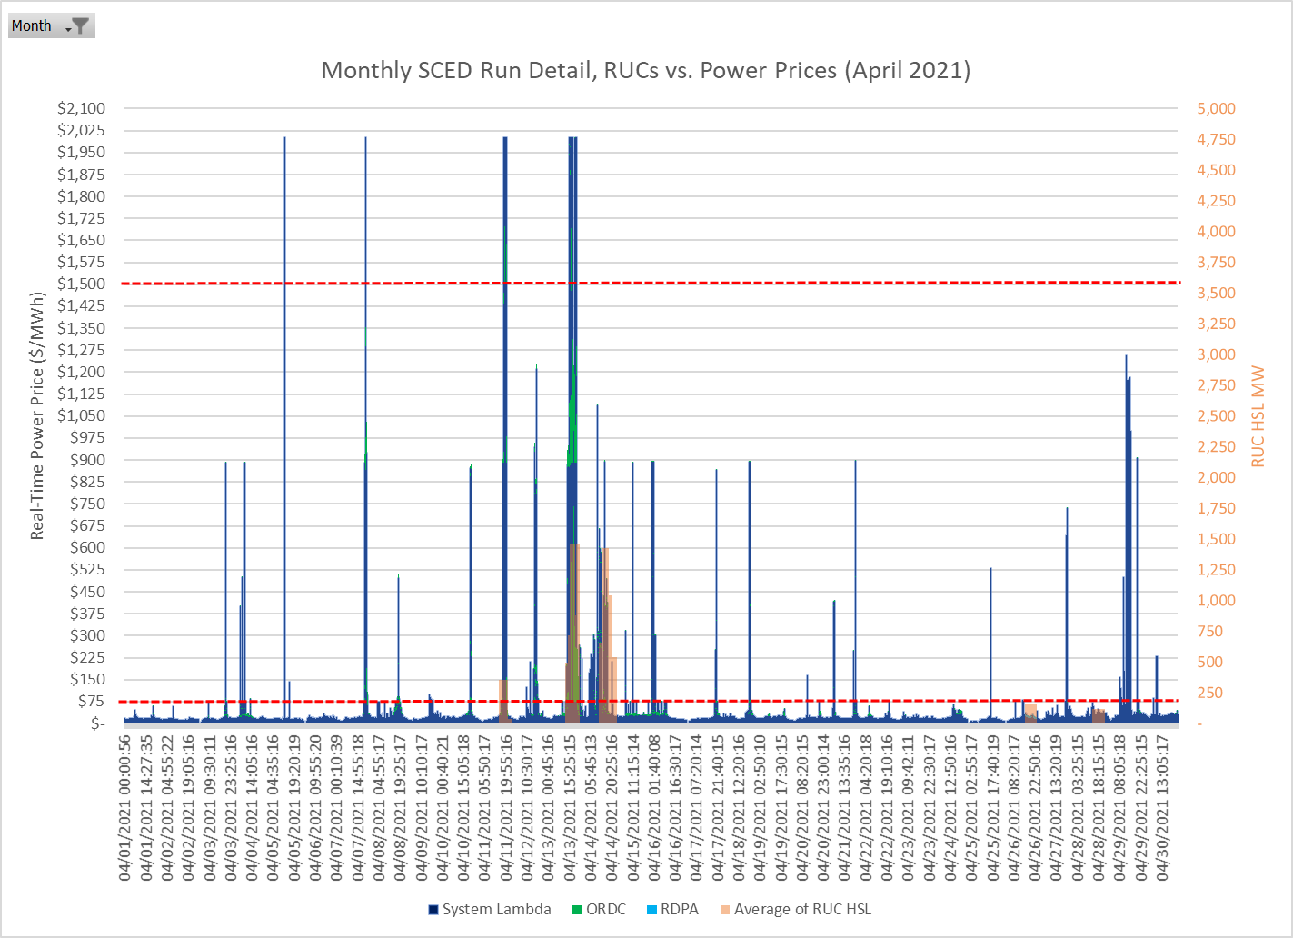
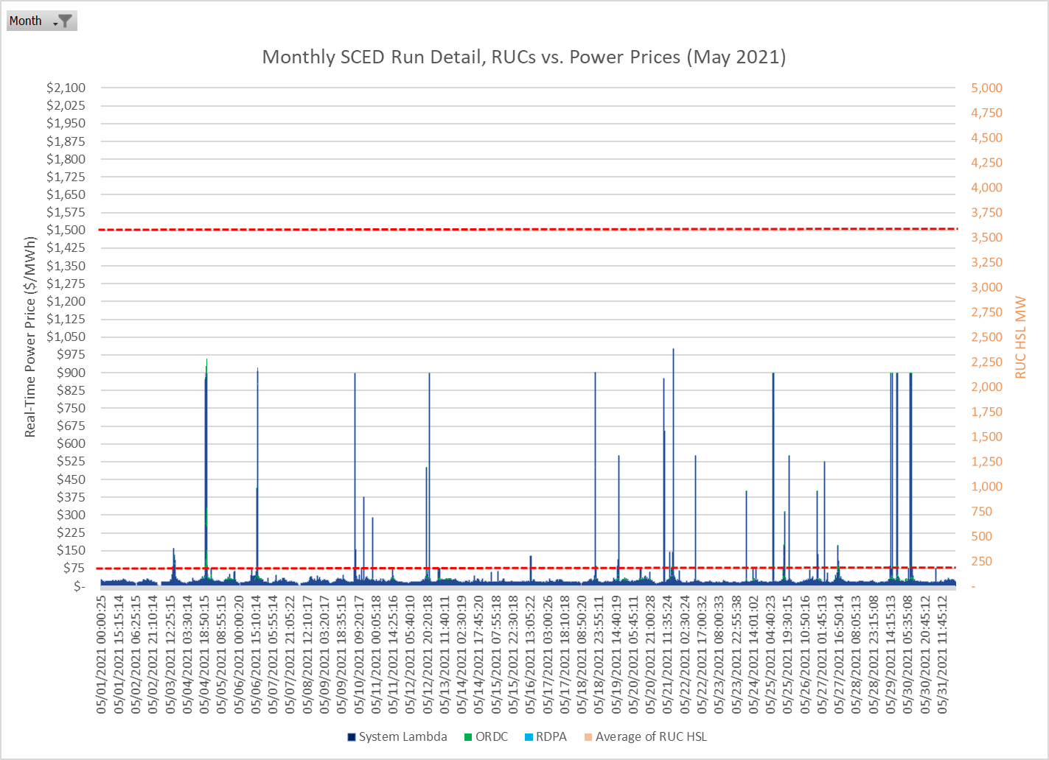
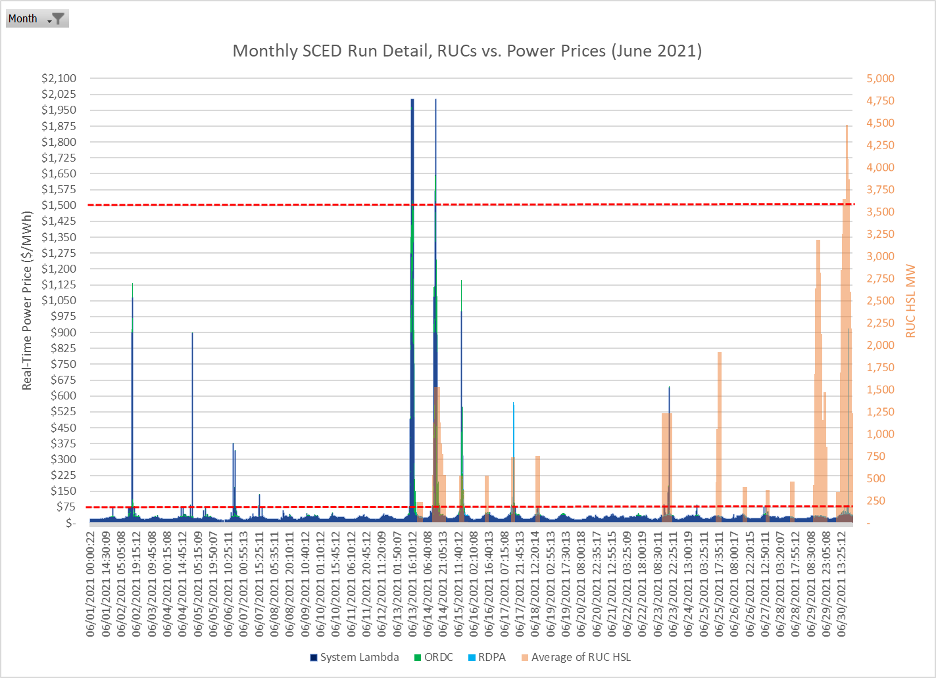
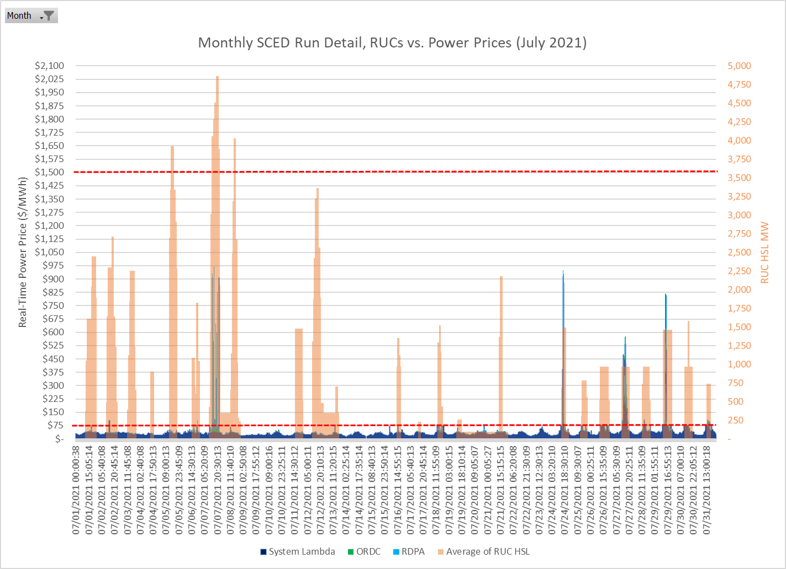
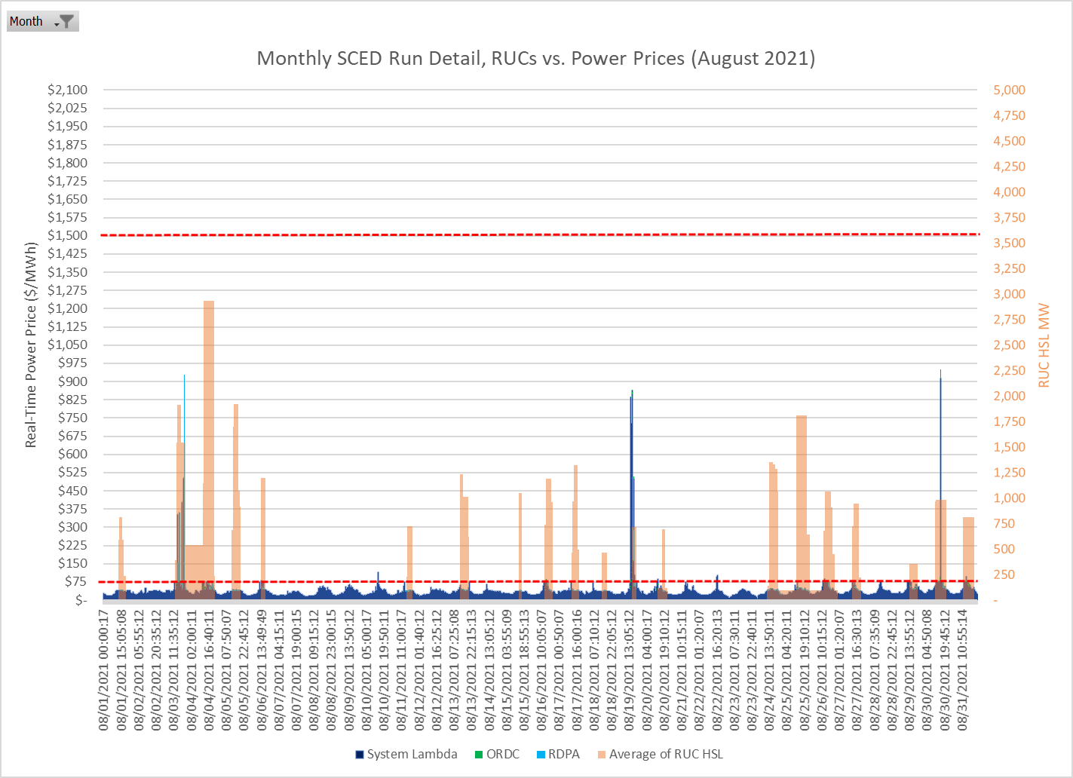
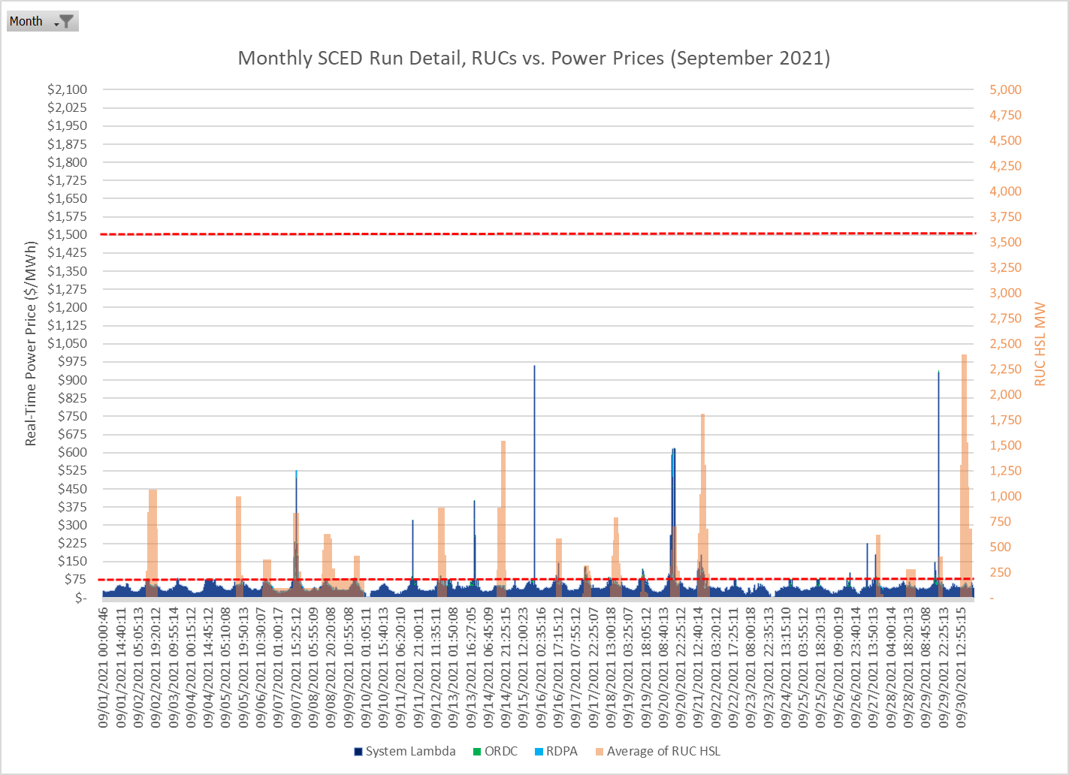
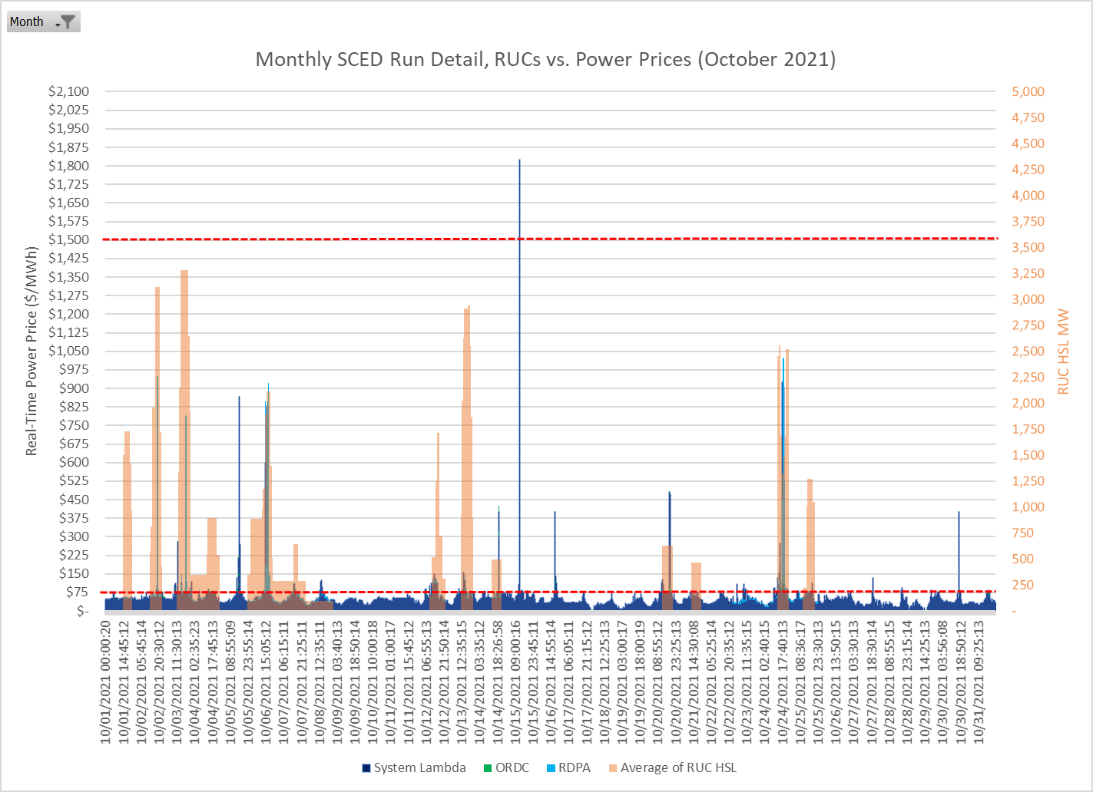
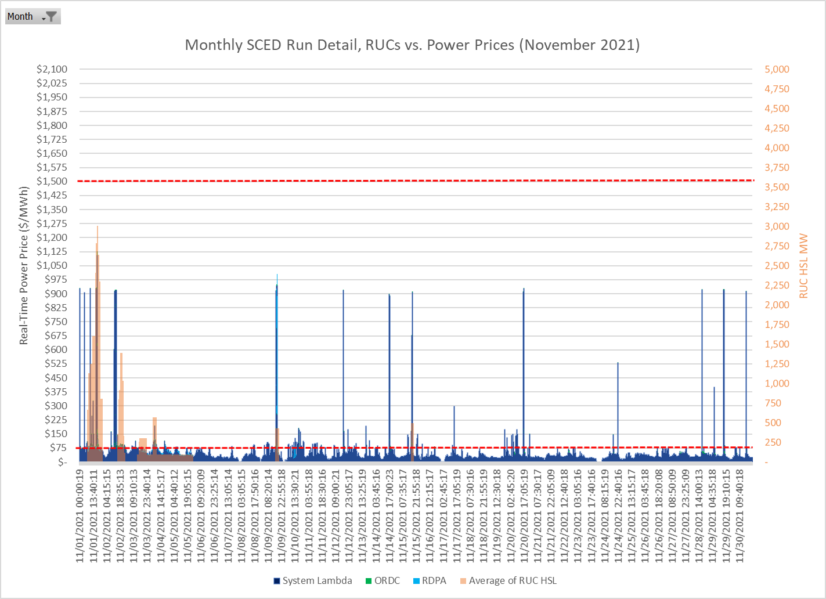
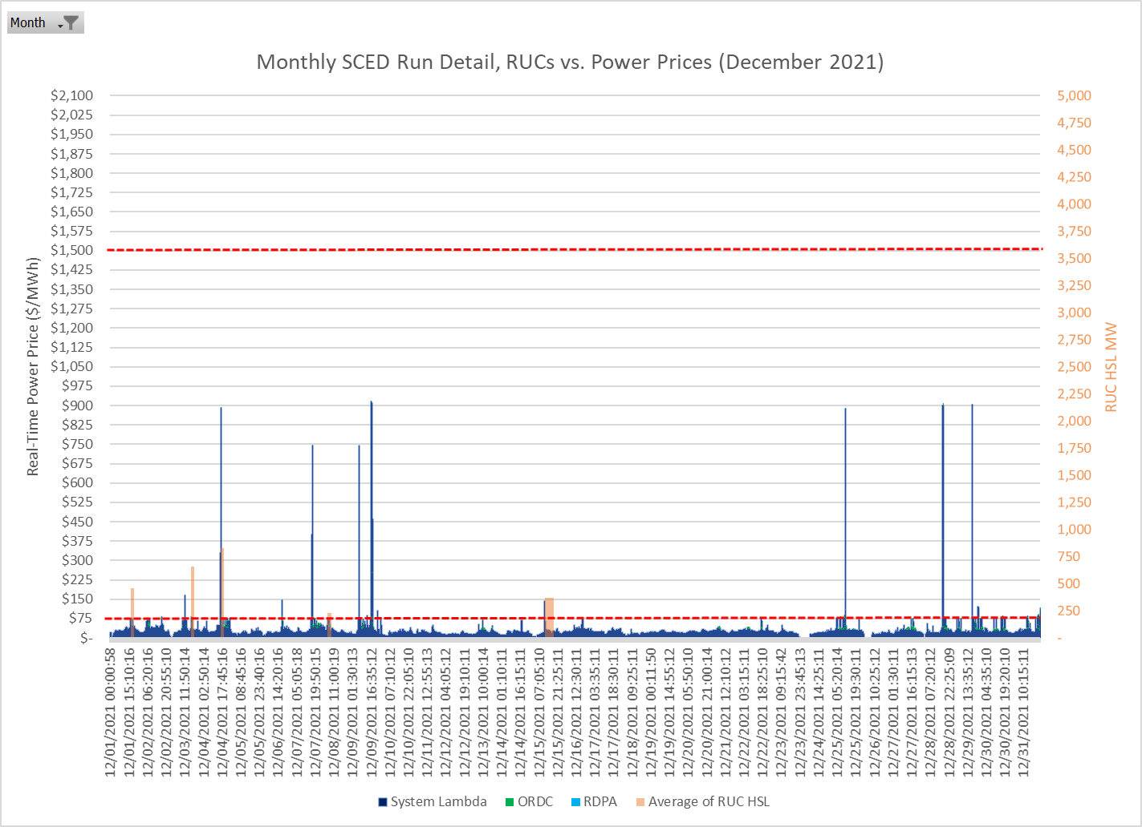
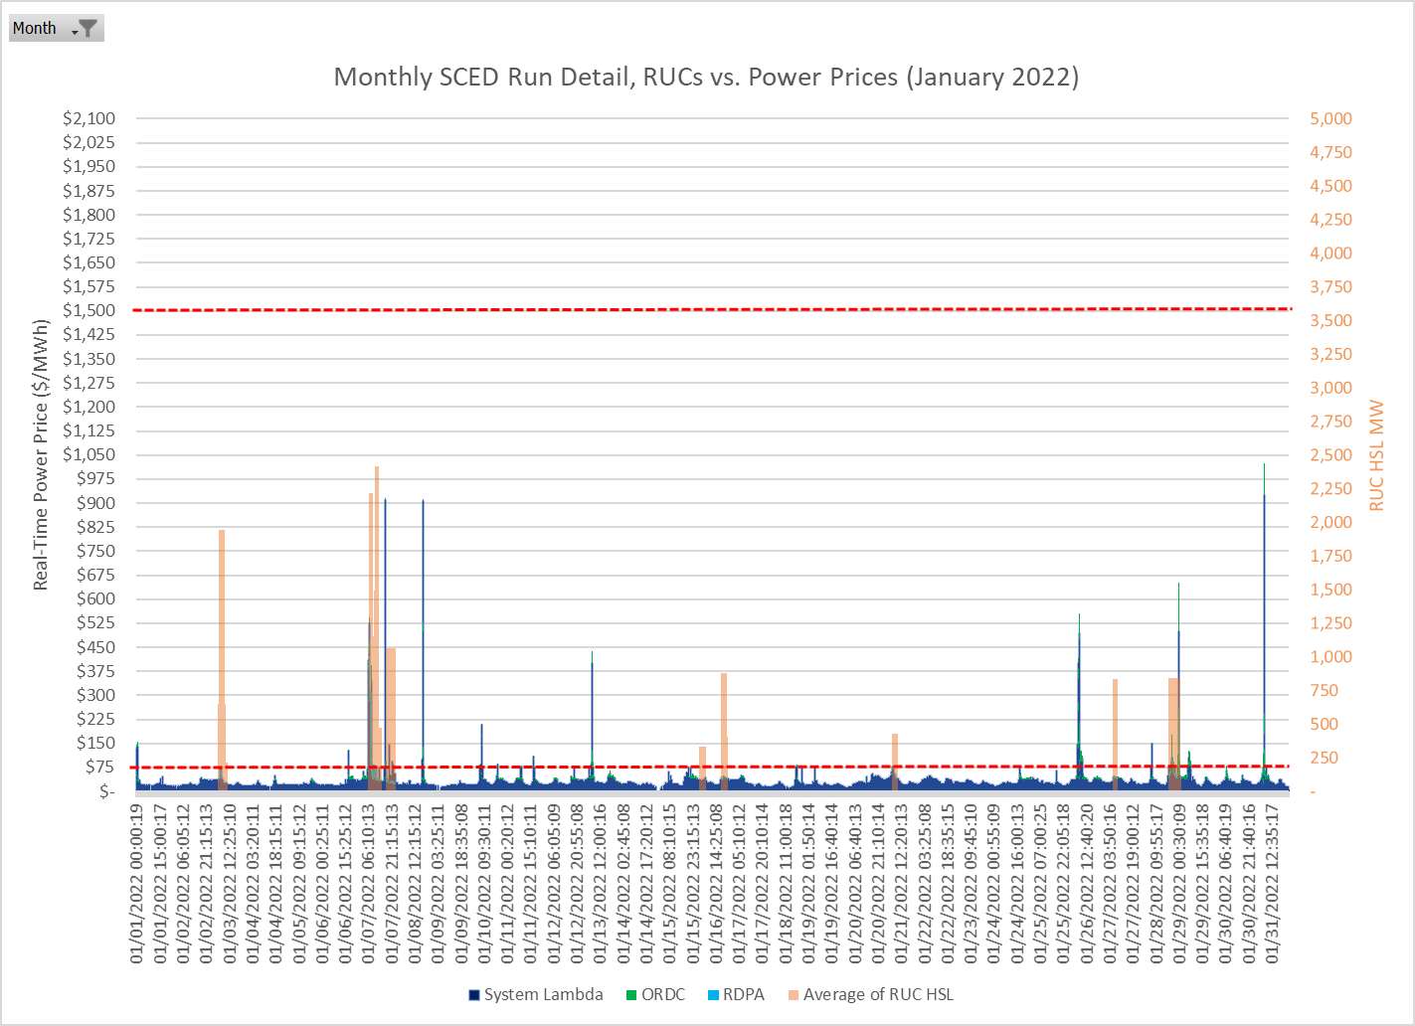
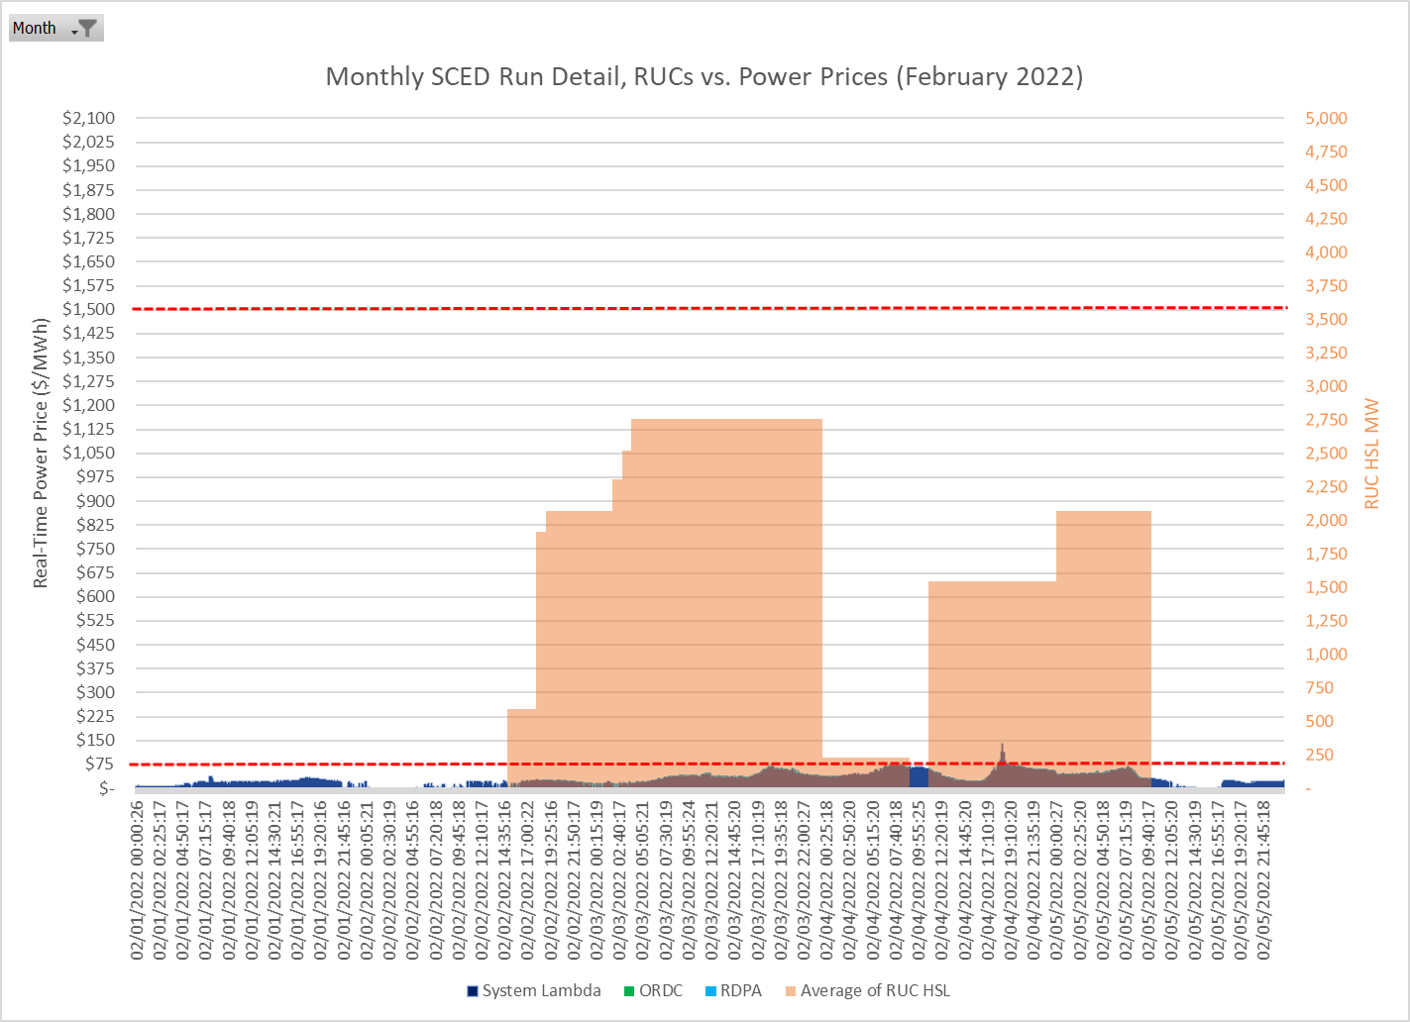

See generally, ERCOT Staff, “Overview of the RUC Commitment Process”, available at https://www.ercot.com/files/docs/2016/10/12/5_-_Overview_of_the_RUC_Process_for_QMWG_-_Final.pptx
For example, see ERCOT’s July 13, 2021 press release: “ERCOT is bringing more generation online sooner if it is needed to balance supply and demand. The grid operator is also purchasing more reserve power, especially on days when the weather forecast is uncertain.” Available at https://www.ercot.com/news/release?id=76fc832e-5306-3d59-9a58-abaa6fa1a4e2
See generally, ERCOT Staff, “Item 15 – 2021 Annual Review of the Market Impacts of RUCs - 013122”, available at https://www.ercot.com/files/docs/2022/01/31/15.%20ERCOT%20Reports.zip
All 9 were observed on June 14, 2021, from the 13:50:15 SCED timestamp to the 14:30:18 SCED timestamp. There were 1,529 MW of RUC HSL capacity during that timeframe. For comparison, there were 180 SCED runs on June 14 that coincided with RUC capacity; the 95% of SCED runs with prices below $1,500/MWh averaged $168.30/MWh.
There are units in the ERCOT stack that are competitively offered at much higher prices than $75/MWh. For instance, Quick-Start combustion turbines often have offers that are several hundred dollars per MWh because of the need to account for operating and maintenance costs that are amortized over very short run times.
When a RUC-committed unit is needed to manage local congestion, the offer is set by the unit’s Mitigated Offer Cap, and so the capacity is not held out of the market by the $1,500 price floor.
Letter from Gov. Abbott to Public Utility Commission of Texas (July 6, 2021): https://gov.texas.gov/uploads/files/press/SCAN_20210706130409.pdf
See Brattle’s November 2021 “Impact Assessment of ORDC Changes” submitted to the Public Utility Commission in Project No. 52373, specifically slide 5: “Which curves will alleviate the need for frequent RUCs?” available at https://interchange.puc.texas.gov/Documents/52373_246_1165964.PDF
Specifically, RUC units that received a DAM three-part offer award for the hour and certain capacity from combined cycle units that are RUC’d from one configuration to another are counted towards online ORDC reserves, and certain RUC capacity with a 30-minute cold start time are counted towards offline ORDC reserves.
PUCT Project No. 31540, Proceeding to Consider Protocols to Implement a Nodal Market in the Electric Reliability Council of Texas Pursuant to P.U.C. Subst. R. 25.501, Direct Testimony of David B. Patton, Potomac Economics Ltd., on behalf of PUCT Staff (November 20, 2005).
See Board Report on NPRR416, available at https://www.ercot.com/files/docs/2012/07/18/416nprr_34_board_report_071712.doc
Regardless of whether the opt-out and clawback penalties are both removed, for the reasons detailed in Section I above, the RUC offer floor needs to be set at a point that puts RUC MWs behind competitive MWs in the offer stack.
See supra footnote 3
PURA § 39.151(d)
16 TAC §§ 22.251 & 25.362(c)

